**ASSIGNMENT-1**

**Question:**

**Create a circuit with Piezo alarm, PIR sensor, Temperature sensor with below functionalities:**

1. **Alarm should sound in one manner if temperature is above 60 C**
2. **Alarm should sound with another frequency of motion is detected in PIR sensor**

**Circuit Diagram:**

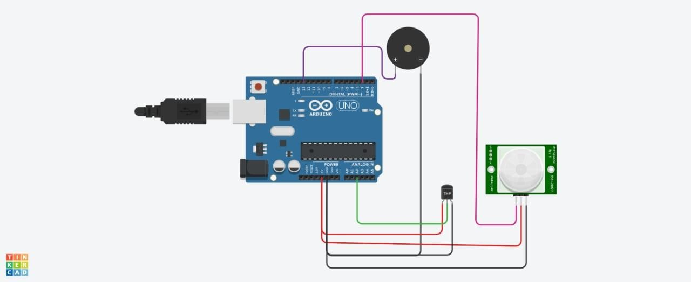

Coding :

void setup()

{

Serial.begin(9600); pinMode(2,INPUT); pinMode(13,OUTPUT);

}

void loop()

{

int motion=digitalRead(2); Serial.print("Position is"); Serial.println(motion); if(motion==1){

tone(13,100); delay(500);

}

else{

noTone(13);

}

double data=analogRead(A2); double n=data/1024;

double volt=n*5; double off=volt-0.5; int temp=off*100;

Serial.print("Temperature is:"); Serial.println(temp); if(temp==60){

tone(13,400); delay(500);

}

else{

noTone(13);

}

}

**OutPut:**

**Temperature above**

**60 C**

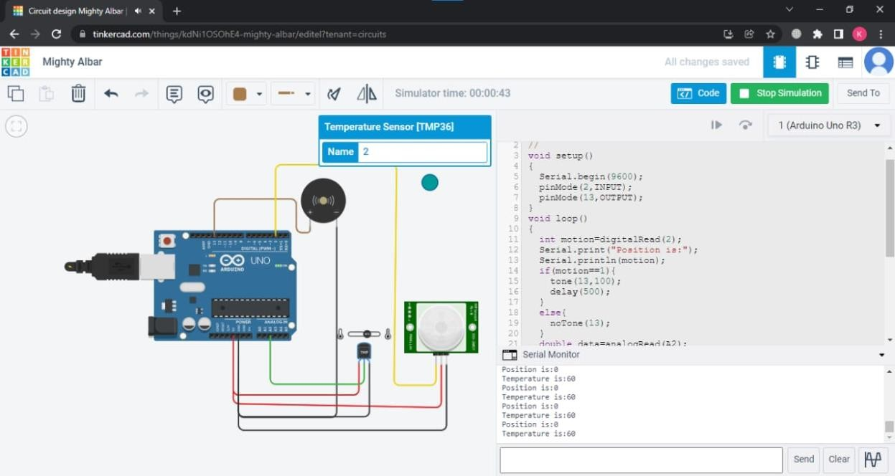

**Motion detection in PIR sensor**

